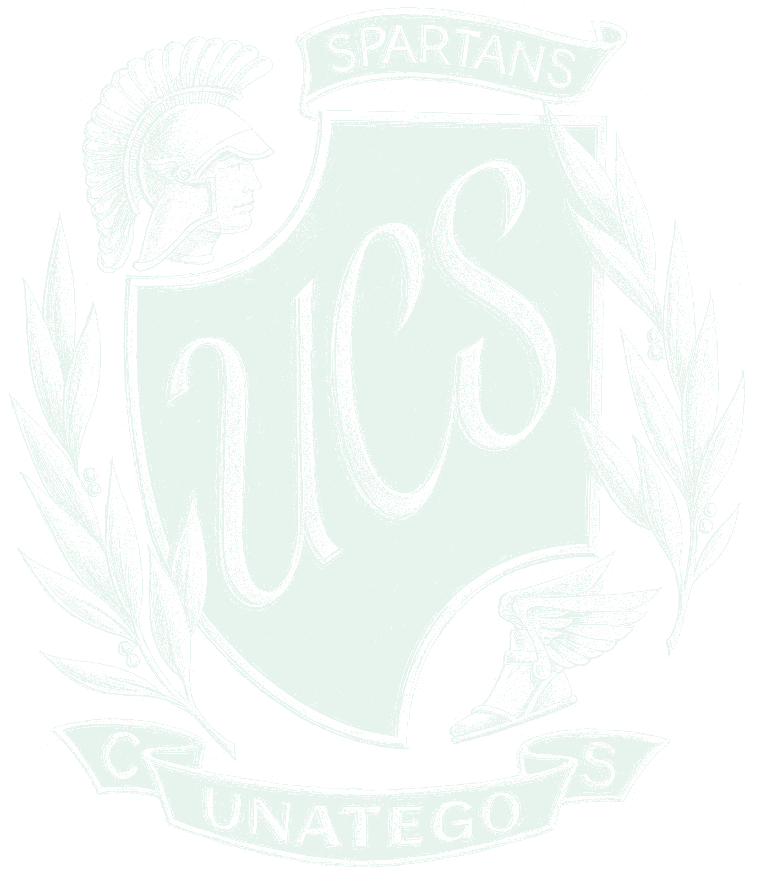
UNATEGO CENTRAL SCHOOL DISTRICT ATHLETIC CODE OF CONDUCT

PREFACE
We intend for our student athletes to represent everything positive that the Unatego School District has to offer. Consequently, our athletes will be held to a higher standard than the non-athlete. Our athletes are, after all, role models for other students and those who will come after them.

In order to instill a sense of pride in our teams, we expect full commitment during practices and competition. We also demand exemplary deportment and sportsmanship from our athletes, both on and off the field, both in-season and during the off-season. Our athletes represent us 365 days a year, therefore, this code of conduct will be in effect year-round.

All policies related to the ACADEMIC STANDARDS set forth in the Academic Policy and ATTENDANCE apply to all students of Unatego Central School District and will be applied accordingly in cooperation with the policies set forth in the ATHLETIC CODE OF CODUCT.

Finally, we expect parents of athletes to help us develop the sense of pride we all expect by supporting their child in living up to the principles of this athletic code. We cannot succeed without your help.

ATHLETIC CODE OF CONDUCT
I will abide by all rules and regulations set forth by the coach/advisor as they have been explained to me.

I will abide by all applicable NYSPHSAA Rules and Regulations
- Physical: the use, possession, sale, and/or distribution of tobacco, alcoholic beverages, and/or illegal drugs are forbidden.
- Scholarship: I must maintain a satisfactory standard according to my ability. I must carry a minimum of three (3) units of academic work and physical education.
- Practice: I will adhere to practice schedules as established by the athletic department.
- Conduct: I will comply with all school policies and procedures, including dress, language, and citizenship. I will demonstrate loyalty to the team, school, and coaches. I will treat ALL others with respect, including students, adults, and school personnel. I will demonstrate a high degree of sportsmanship.

Students may be suspended or dismissed from the team if they are found to have violated any of the rules covered in this Code of Conduct, the Student Handbook, and/or Board Policies.

RIGHT TO APPEAL

An individual has the right to appeal a decision made concerning the enforcement of this Code of Conduct. The appeal must be made to the high school principal, in writing, within ten (10) days of the

decision being rendered. The principal will then investigate the matter and make a decision based on that investigation.

Appeal of the principal’s decision shall be in writing to the Superintendent of Schools within ten (10) days of the principal’s decision.

Appeal of the Superintendent’s decision shall be in writing to the Board of Education within ten (10) days of the Superintendent’s decision.

The right to appeal shall be limited to a review of adherence to the written policy.

RANGE OF PENALTIES FOR TABACCO/ALCOHOL/DRUG USE
This code of conduct will be in effect year-round.
Any team member determined by school personnel or legal authorities to be using, possessing, selling, distributing, or under the influence of tobacco, illegal drugs, alcohol beverages, and/or to be in attendance at a social gathering where tobacco, illegal drugs, alcohol beverages are used illegally will be subject to a range of penalties as follows:

- A first violation will result in an immediate suspension of thirty-three percent (33%) of competitions during the current sports season. The student and person in parental relationship will be given an opportunity for an informal conference to discuss the conduct in question. The period of suspension will carry forward to another sports season or another academic year if there is less than 33% of the season remaining in the current sport season. A suspended athlete may participate in tryouts for a team in another sports season.
  - It is expected that the athlete will attend and participate in practices during the time of suspension. The athlete will attend competitions but will not dress in his/her uniform.
  - An educational program may be prescribed for the athlete as a condition of reinstatement.
  - If the student/athlete refuses to follow the rules established under this Code of Conduct, the athlete will be suspended from all teams for one entire calendar year.
  - An athlete is expected to complete the sports season in which the suspension begins. Failure to complete the season does not terminate the suspension, as it may be carried over to the next sport season.
  - A violation of the Code of Conduct may result in the denial of any athletic awards.
  - Students who have been assigned out of school suspension are not allowed to participate in interscholastic athletics during their suspension.
- A second violation will result in an immediate suspension of sixty-six percent (66%) of the competitions during the current sports season AND the completion of an approved educational program. The period of suspension will carry forward to another sports season or another academic year if there is less than 66% of the season remaining in the current sport season. Letters A-D apply as well for the second offence. A suspended athlete may participate in tryouts for a team in another sports season.
- A third violation will result in a suspension for the duration of the student’s academic career.

A written petition to reinstate may be considered following, at a minimum, a full calendar year of suspension, EXEMPLARY citizenship, ACADEMIC performance, AND adherence to all athletic and school policies. A petition to reinstate must be submitted to the principal, and will be considered by a committee containing, at a minimum, the principal, the athletic direction, and the superintendent or their designee. A decision will be rendered in writing to the parents/student within ten (10) days from submission.

Parents will be notified, in writing, as each incident occurs. If a decision has been delayed, pending an investigation, the student will be suspended from the participation until a decision has been made.

RISK OF INJURY STATEMENT AND ATHLETIC CONSENT
I am also aware that competing and/or practicing in any athletic activity can be a dangerous activity involving risk of injury. I understand that the dangers and risks of competing and practicing in the activity include, but are not limited to death, neck, and spinal injury which may result in complete and/or partial paralysis, brain damage, injury to virtually all bones, joints, ligaments, muscles, tendons, and other aspects of a muscular-skeletal system and injury or impairment of future abilities to earn a living, to engage in business, social, and recreational activities, and generally to enjoy life.

If I am a participant in baseball, softball, football, soccer, basketball, and/or wrestling, I specifically acknowledge that it is a contact sport involving even greater risk of injury than other sports.

Due to the possible dangers of participating in the activities, I recognize the importance of following the coaches’ instructions regarding playing techniques, training and other team rules, and agree to obey such instructions.

In consideration of the school district permitting me to try out for and to engage in all activities related to the team including, but not limited to, trying out, practicing, or participating in that activity, I hereby assume all risks associated with participation.

